**Assignment 6:**

1. The size of any newly created file is zero. Therefore when we remove the only write statement to fdout, memcpy throws a bus error as it tries to write beyond the end of the file. Instead of lseek and write we can also use ftruncate(fdout, statbuf.st_size).



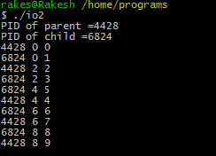

The counter is increased linearly although it is used by two threads simultaneously.